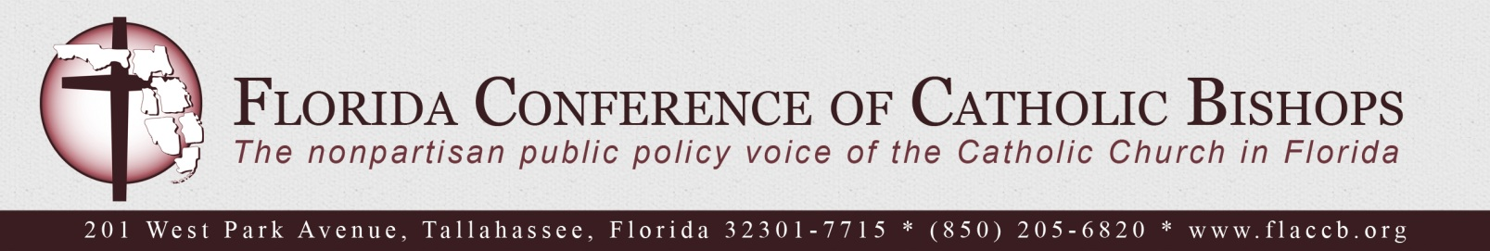

A Statement by the Bishops of Florida in Support of Immigration Reform
June 5, 2013

“When an alien resides with you in your land, do not molest him. You shall treat the alien who resides with you no differently than the natives born among you; have the same love for him as for yourself; for you too were once aliens in the land of Egypt. I, the Lord am your God.” Leviticus 19: 33 – 34

We, the Catholic Bishops of Florida, are deeply concerned about our nation’s immigration system. We lament the loss of the many years our migrant brothers and sisters have waited for changes that would enable them to seek legal protection and support their families.

While the Catholic Church acknowledges the right of countries to control their borders and enforce immigration laws, the common good is not served when the human dignity and rights of individuals are violated. The Church teaches, the more prosperous nations are obliged, to the extent they are able, to welcome the foreigner in search of the security and the means of livelihood which he cannot find in his country of origin. Public authorities should see to it that the natural right is respected that places a guest under the protection of those who receive him (Catechism of the Catholic Church, 2241).

The Florida economy is dependent upon manual labor for agriculture, construction and the service industry. People who seek to escape persecution and economic disparity in their country of origin have come to America for this employment. While the need for labor exists, the limited numbers of worker visas to bring labor into America are insufficient and have created a market for undocumented workers who may face abuses by unscrupulous employers, human smugglers and human traffickers.

Congress has the best opportunity in almost 30 years to pass immigration reform. This is a historic moment in our country. As Americans, we cannot let this moment pass. As a moral matter, our country must not accept the toil and taxes of these children of God without offering them the protections of our laws, which they so willingly seek.

We urge you to join with us in asking the 113th Congress to support immigration reform that:

- Provides a path to citizenship for undocumented persons in the country;
- Preserves family unity by reducing backlogs and waiting times for family reunification;
- Protects vulnerable populations including refugees, asylum seekers and unaccompanied children;
- Addresses the root causes of migration, such as persecution and economic disparity.

Now is the time to act. We, the Catholic Bishops of Florida, ask our parishioners to contact their member of Congress and two United States Senators to ask them to support immigration reform. Messages may be sent electronically by visiting www.flaccb.org/lawmakers.php.

Most Reverend Thomas G. Wenski  Archdiocese of Miami | Most Reverend Gerald M. Barbarito  Diocese of Palm Beach | Most Reverend Robert N. Lynch  Diocese of St. Petersburg
Most Reverend Frank J. Dewane  Diocese of Venice | Most Reverend John G. Noonan  Diocese of Orlando | Most Reverend Felipe J. Estévez  Diocese of St. Augustine
Most Reverend Gregory L. Parkes
Diocese of Pensacola-Tallahassee

