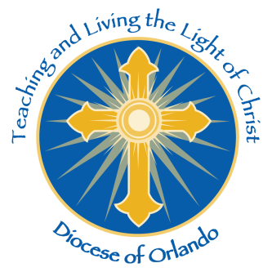



**General Guidelines for Application**

Applicants must be 1) a Catholic (arch)diocese, or 2) a recognized Catholic missionary society in good standing serving in foreign countries or in dioceses in the United States designated as missionary by the U.S. Conference of Catholic Bishops’ Home Missions Office.

• Missions must complete and submit a new application each year.

• Regrettably, we generally cannot re-approve Mission Co-Op participants who have visited us within the last 5 years

• Please do not request Mass stipends through the Mission Co-op program.

• Missionary groups may not hand out pre-printed envelopes or materials that in any way attempt to collect names and addresses of parishioners for the purpose of future mail or phone solicitations. Solicitation for sponsorship of specific/named individuals (i.e., orphans, students, seminarians, etc.) is not allowed.

• The MCP appeal weekend requires a speaker to appear in person at the Masses to make an appeal for prayers and financial assistance. Groups may not request that a letter be read at the Masses and a collection taken in lieu of a personal appearance.

• The Diocese of Orlando has many Spanish-speaking parishes. Please let us know if you have a bi-lingual speaker who is native or fluent in Spanish.

• The Diocese of Orlando and its parishes generally do not provide for or reimburse travel costs, shuttle service to or from the airport, or lodging accommodations. It is the speaker’s responsibility to provide for his or her own housing arrangements as well as transportation between parish sites and/or the airport.

Thank you for your application to the Diocese of Orlando Missionary Cooperation Plan. Applications for 2024 will be received until May 31, 2023. Accepted missions will receive a letter from the Diocese of Orlando. Please be advised that you will only hear from us if your mission group is accepted.

You can email, fax or mail your application to:

**Diocese of Orlando**

**Mission Integration & Engagement**

**PO Box 1800, Orlando, FL 32802-1800**

[**mie@orlandodiocese.org**](mailto:mie@orlandodiocese.org)

**Phone: 407-246-4922 FAX: 407-246-4942**

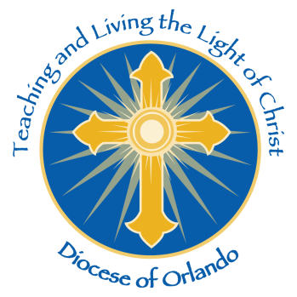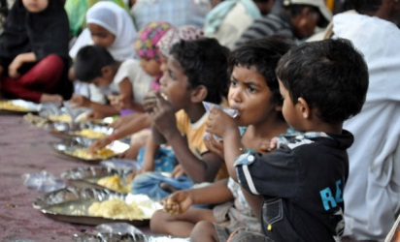

**DIOCESE OF ORLANDO, FLORIDA**

**MISSIONARY COOPERATIVE PLAN**

**2024 APPLICATION FORM**

**Regrettably, we generally cannot re-approve**

**Mission Co-Op participants who have visited us**

**within the last 5 years**

Mission Integration & Engagement

**Name of Group Requesting Participation:** ___________________________________________________________

In what diocese and county is the mission located: ____________________________________________________

**Mailing Address** __________________________________________________________________________

__________________________________________________________________________

__________________________________________________________________________

**Telephone Number** ____________________________ **Fax Number** ____________________________

**E-mail Address** _________________________________________________________________________________

**Name of Contact Person in United States:** _____________________________________________________

**Address:** _________________________________________

_________________________________________

_________________________________________

**Telephone Number** _________________________**E-Mail Address** _______________________________________

***Please respond to the following by circling Yes or No.***

**Does your Bishop or Superior support your application & participation in Mission Co-Op?** Yes No

**Are you a MCP participant in other dioceses in the U.S.?** Yes No

**Have you participated in our diocese previously?** Yes No

**(when/ how often?)**__________________________

**Do you have a religious affiliation/personal contact in the diocese?** Yes No

**Name of group, person, town/city?** _____________________________

**Will the person doing the appeal have personal mission experience?** Yes No

**Specific Countries/areas you serve:** ________________________________________________________________________________________________________________________________________________________________________________________

**Will the person be able to *communicate clearly and effectively in English*?** Yes No

**Will the person you send be bilingual (English & Spanish speaking)?** Si No

**Will the person be able to celebrate the liturgy of the Mass?**  Yes No

**\*Are you able to provide transportation for the person during the mission visit?** Yes No

**\*Can you arrange for the person’s accommodations?** Yes No

**Is the person willing to travel to any place in the diocese?** Yes No

**The person’s point of origin for traveling**  _______________________________________

**How do you plan to use the MCP appeal monies? Please be as concise, yet specific as possible**.

___________________________________________________________________________________

___________________________________________________________________________________

___________________________________________________________________________________

___________________________________________________________________________________

**What are the monetary/missionary expectations relative to your inclusion in our MCP?**

__________________________________________________________________________________

__________________________________________________________________________________

__________________________________________________________________________________

__________________________________________________________________________________

**Other comments: (If a new applicant, please provide referrals from other dioceses visited)**

__________________________________________________________________________________

__________________________________________________________________________________

__________________________________________________________________________________

**PLEASE RETURN THIS COMPLETED APPLICATION ONLY TO:**

**Diocese of Orlando**

**Mission Integration & Engagement**

**PO Box 1800, Orlando, FL 32802-1800**

**Email: mie@orlandodiocese.org**

**Phone: 407-246-4922 FAX: 407-246-4942**

**Initial screening of applications will begin immediately upon arrival. Decisions on 2023 Participants will happen quarterly. We will accept applications for 2024 until May 31, 2023.**  **Please apply early.**