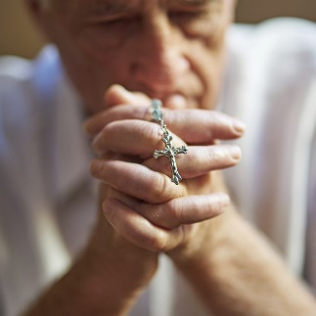“It is not right for us to neglect the word of God to serve at table. Brothers, select from among you seven reputable men, filled with the Spirit and wisdom, whom we shall appoint to this task, whereas we shall devote ourselves to prayer and to the ministry of the word.” (Acts 6:2-4)

The Diocese of Orlando, Office of the Permanent Diaconate is calling on the Church community to bring forth reputable men, servants, filled with the Spirit, to discern a call to the permanent diaconate. Men seeking to discern this call are encouraged to attend a Diaconate Discernment Night. Six discernment sessions will be held throughout the diocese in September and October. All session are 6:30 p.m. – 8:30 p.m.

* *9/11/25 St. Joseph Catholic Church, 210 W. Lemon St., Lakeland*
* *9/17/25 St. Charles Borromeo Catholic Church, 4001 Edgewater Dr., Orlando*
* *9/18/25 St. John the Evangelist Catholic Church, 5655 Stadium Pkwy., Viera*
* *9/23/25 Church of the Epiphany, 201 Lafayette St., Port Orange*
* *9/24/25 St. John Vianney Catholic Church, 6200 S Orange Blossom Trail, Orlando*
* *9/25/25 St. Timothy Catholic Church, 1351 Paige Place, Lady Lake*

For more information, go to <https://www.orlandodiocese.org/diaconate-discernment/>

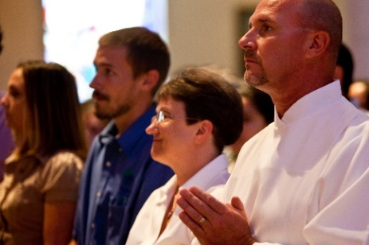The call to the diaconate is a call to service of Liturgy, Word and Charity. This call does not come to the individual alone, nor for his own sake. It is not a right, but rather it is a call affirmed and recognized by the Church in testimony of the man who is living a life of service to God, family, parish, and community.

The Diocese of Orlando, Office of the Permanent Diaconate is calling on the Church community to bring forth reputable men, servants, filled with the Spirit, to discern a call to the permanent diaconate. Men seeking to discern this call are encouraged to attend a Diaconate Discernment Night. Six discernment sessions will be held throughout the diocese in September and October. All session are 6:30 p.m. – 8:30 p.m.

* *9/11/25 St. Joseph Catholic Church, 210 W. Lemon St., Lakeland*
* *9/17/25 St. Charles Borromeo Catholic Church, 4001 Edgewater Dr., Orlando*
* *9/18/25 St. John the Evangelist Catholic Church, 5655 Stadium Pkwy., Viera*
* *9/23/25 Church of the Epiphany, 201 Lafayette St., Port Orange*
* *9/24/25 St. John Vianney Catholic Church, 6200 S Orange Blossom Trail, Orlando*
* *9/25/25 St. Timothy Catholic Church, 1351 Paige Place, Lady Lake*

For more information, go to <https://www.orlandodiocese.org/diaconate-discernment/>

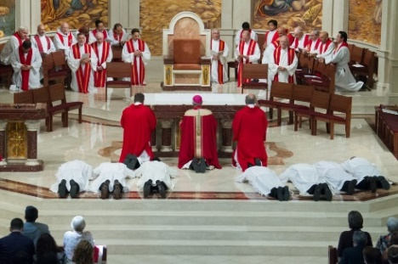The Diocese of Orlando has 250 permanent deacons and another 51 in formation. Diaconate Formation is a comprehensive ministry formation process involving the four pillars of human, spiritual, pastoral, and intellectual formation. This 6-year formation process prepares the deacon for his lifelong vocation and ministry of Liturgy, Word, and Charity.

The Diocese of Orlando, Office of the Permanent Diaconate is calling on the Church community to bring forth reputable men, servants, filled with the Spirit, to discern a call to the permanent diaconate. Men seeking to discern this call are encouraged to attend a Diaconate Discernment Night. Six discernment sessions will be held throughout the diocese in September and October. All session are 6:30 p.m. – 8:30 p.m.

* *9/11/25 St. Joseph Catholic Church, 210 W. Lemon St., Lakeland*
* *9/17/25 St. Charles Borromeo Catholic Church, 4001 Edgewater Dr., Orlando*
* *9/18/25 St. John the Evangelist Catholic Church, 5655 Stadium Pkwy., Viera*
* *9/23/25 Church of the Epiphany, 201 Lafayette St., Port Orange*
* *9/24/25 St. John Vianney Catholic Church, 6200 S Orange Blossom Trail, Orlando*
* *9/25/25 St. Timothy Catholic Church, 1351 Paige Place, Lady Lake*

For more information, go to <https://www.orlandodiocese.org/diaconate-discernment/>

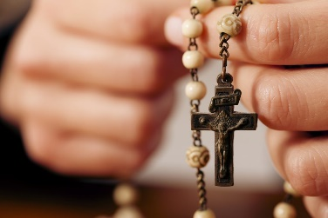“Deacons must be dignified, not deceitful, not addicted to drink, not greedy for sordid gain, holding fast to the mystery of the faith with a clear conscience. Moreover, they should be tested first; then, if there is nothing against them, let them serve as deacons. Deacons may be married only once and must manage their children and their households well.” (1 Tm 3:8-10,12)

The Diocese of Orlando, Office of the Permanent Diaconate is calling on the Church community to bring forth reputable men, servants, filled with the Spirit, to discern a call to the permanent diaconate. Men seeking to discern this call are encouraged to attend a Diaconate Discernment Night. Six discernment sessions will be held throughout the diocese in September and October. All session are 6:30 p.m. – 8:30 p.m.

* *9/11/25 St. Joseph Catholic Church, 210 W. Lemon St., Lakeland*
* *9/17/25 St. Charles Borromeo Catholic Church, 4001 Edgewater Dr., Orlando*
* *9/18/25 St. John the Evangelist Catholic Church, 5655 Stadium Pkwy., Viera*
* *9/23/25 Church of the Epiphany, 201 Lafayette St., Port Orange*
* *9/24/25 St. John Vianney Catholic Church, 6200 S Orange Blossom Trail, Orlando*
* *9/25/25 St. Timothy Catholic Church, 1351 Paige Place, Lady Lake*

For more information, go to <https://www.orlandodiocese.org/diaconate-discernment/>